4.Write a Java servlet program to get the student registration details and display the same with the same servlet program.

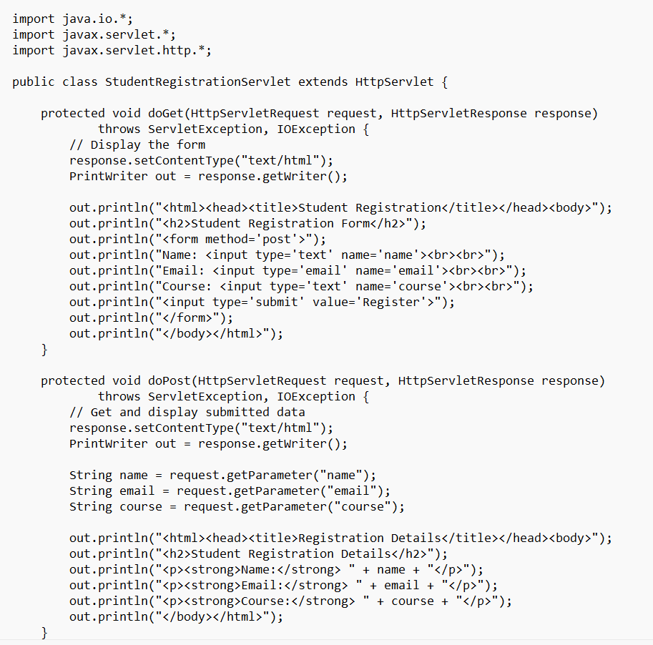
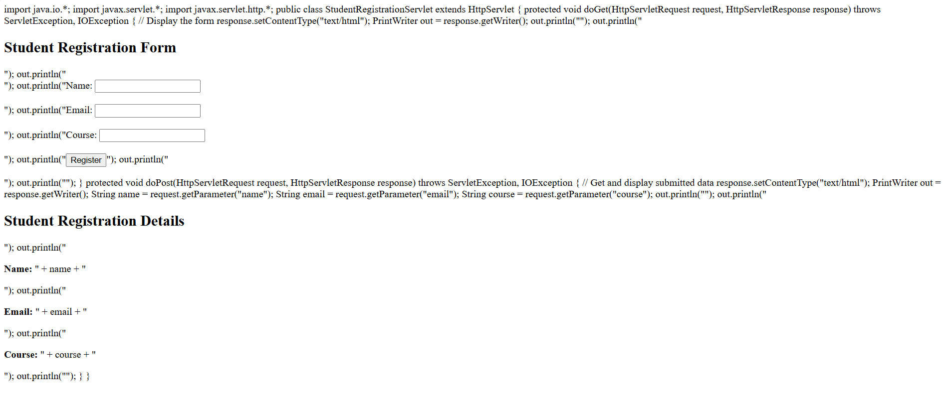
output

